Ex.No.8 Develop a simple calculator using XMLRPC

AIM:
To develop a simple calculator using XMLRPC using Python.
Introduction: XML-RPC:
XML-RPC is a protocol that uses XML to encode remote procedure calls (RPC) and
HTTP as a transport mechanism, allowing a client to call functions on a remote server over
a network.
ALGORITHM:
CLIENT:
1. Start the program.
2. Import the xmlrpc.client module.
3. Create a connection to the XML-RPC server using ServerProxy.
4. Display the calculator menu:
o Addition
o Subtraction
o Multiplication
o Division
o Exit
5. Read the user&#39;s choice.
6. If the user selects Exit, terminate the program.
7. Otherwise, read two input numbers.
8. Send the selected operation and the two numbers to the server.
9. Receive the result from the server.
10. Display the result.
11. Repeat Steps 4–10 until the user chooses Exit.
12. End the program.
SERVER:
1. Start the program.
2. Import the SimpleXMLRPCServer module.
3. Define the calculator functions:
Addition
Subtraction
Multiplication
Division (check for division by zero).
4. Create an XML-RPC server on localhost with port 8000.
5. Register all the calculator functions with the server.
6. Display the message &quot;XML-RPC Server is Running on Port 8000...&quot;.
7. Wait for client requests.
8. When a client sends a request:
9. Execute the requested arithmetic operation.
10. Return the result to the client.
11. Continue serving requests until the server is manually stopped.
12. End the program.

PROGRAM CODE:
SERVER:
from xmlrpc.server import SimpleXMLRPCServer
# Calculator Functions
def add(a, b):
return a + b
def sub(a, b):
return a - b
def mul(a, b):
return a * b
def div(a, b):
if b == 0:
return &quot;Error! Division by Zero&quot;
return a / b
# Create XML-RPC Server
server = SimpleXMLRPCServer((&quot;localhost&quot;, 8000))
print(&quot;XML-RPC Server is Running on Port 8000...&quot;)
# Register Functions
server.register_function(add, &quot;add&quot;)
server.register_function(sub, &quot;sub&quot;)
server.register_function(mul, &quot;mul&quot;)
server.register_function(div, &quot;div&quot;)
# Keep Server Running
server.serve_forever()

CLIENT:
import xmlrpc.client
# Connect to Server
proxy = xmlrpc.client.ServerProxy(&quot;http://localhost:8000/&quot;)
while True:
print(&quot;\n------ XML-RPC Calculator ------&quot;)
print(&quot;1. Addition&quot;)
print(&quot;2. Subtraction&quot;)
print(&quot;3. Multiplication&quot;)
print(&quot;4. Division&quot;)
print(&quot;5. Exit&quot;)
choice = int(input(&quot;Enter your Choice: &quot;))
if choice == 5:
print(&quot;Calculator Closed.&quot;)
break
a = float(input(&quot;Enter First Number: &quot;))
b = float(input(&quot;Enter Second Number: &quot;))
if choice == 1:
print(&quot;Result =&quot;, proxy.add(a, b))
elif choice == 2:
print(&quot;Result =&quot;, proxy.sub(a, b))
elif choice == 3:
print(&quot;Result =&quot;, proxy.mul(a, b))
elif choice == 4:
print(&quot;Result =&quot;, proxy.div(a, b))
else:
print(&quot;Invalid Choice&quot;)
SAMPLE OUTPUT:
SERVER:
XML-RPC Server is Running on Port 8000...
127.0.0.1 - - [09/Jul/2026 11:05:10] &quot;POST /RPC2 HTTP/1.1&quot; 200 -
127.0.0.1 - - [09/Jul/2026 11:05:24] &quot;POST /RPC2 HTTP/1.1&quot; 200 -
127.0.0.1 - - [09/Jul/2026 11:05:38] &quot;POST /RPC2 HTTP/1.1&quot; 200 -
127.0.0.1 - - [09/Jul/2026 11:05:52] &quot;POST /RPC2 HTTP/1.1&quot; 200 -
CLIENT:
------ XML-RPC Calculator ------
1. Addition
2. Subtraction
3. Multiplication

4. Division
5. Exit
Enter your Choice: 1
Enter First Number: 15
Enter Second Number: 10
Result = 25.0
------ XML-RPC Calculator ------
1. Addition
2. Subtraction
3. Multiplication
4. Division
5. Exit
Enter your Choice: 2
Enter First Number: 15
Enter Second Number: 10
Result = 5.0
------ XML-RPC Calculator ------
1. Addition
2. Subtraction
3. Multiplication
4. Division
5. Exit
Enter your Choice: 3
Enter First Number: 15
Enter Second Number: 10
Result = 150.0
------ XML-RPC Calculator ------
1. Addition
2. Subtraction
3. Multiplication
4. Division
5. Exit
Enter your Choice: 4
Enter First Number: 15
Enter Second Number: 10
Result = 1.5
------ XML-RPC Calculator ------
1. Addition
2. Subtraction
3. Multiplication
4. Division
5. Exit

Enter your Choice: 4
Enter First Number: 15
Enter Second Number: 0
Result = Error! Division by Zero
------ XML-RPC Calculator ------
1. Addition
2. Subtraction
3. Multiplication
4. Division
5. Exit
Enter your Choice: 5
Calculator Closed.

OUTPUT:

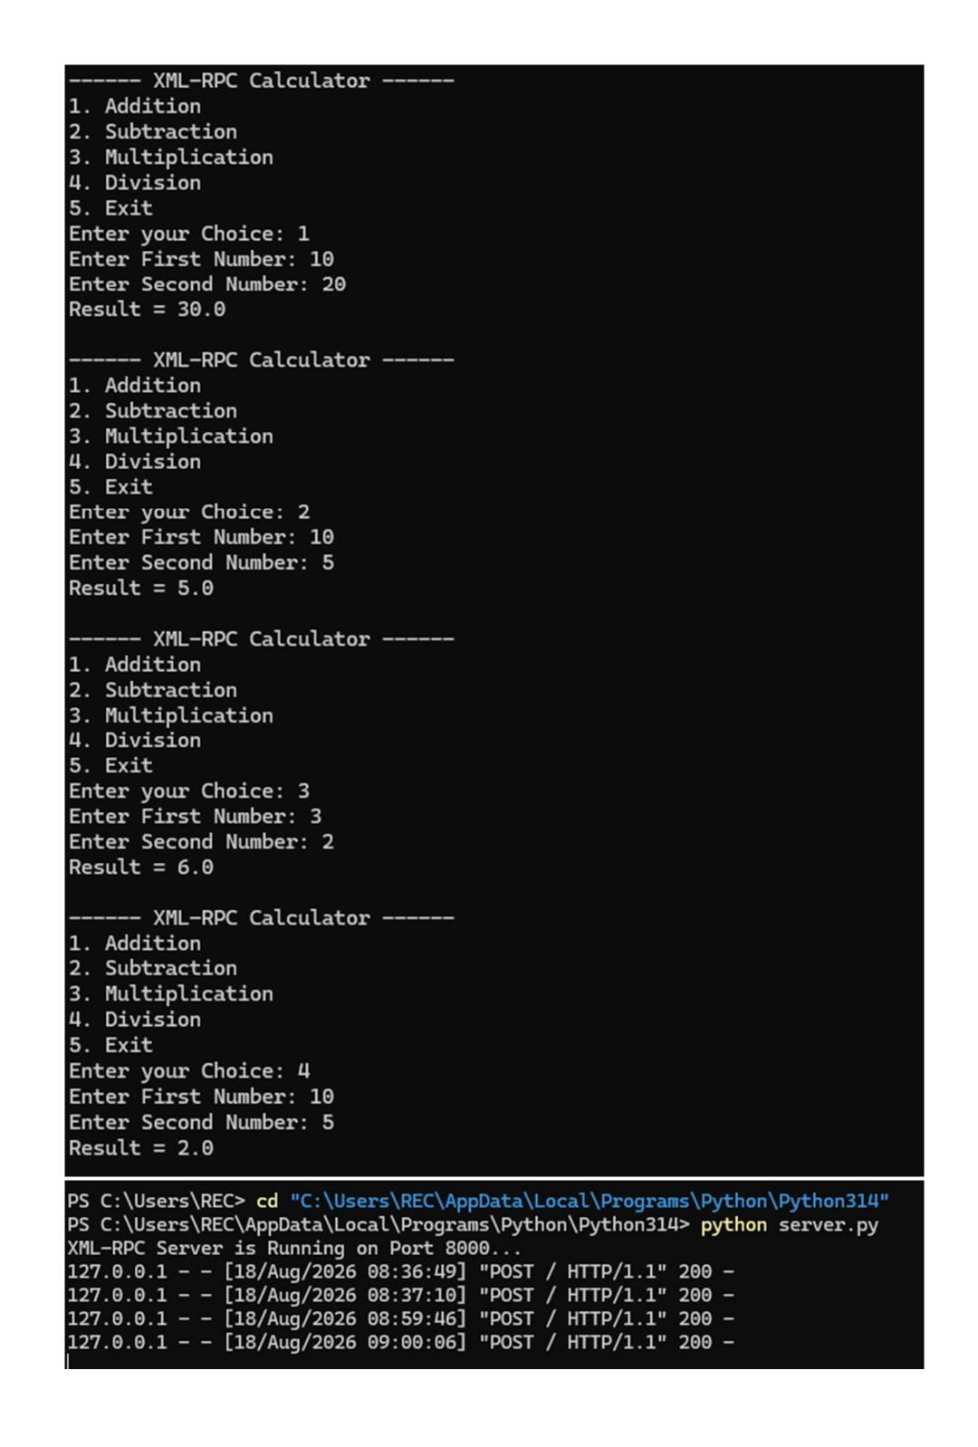

RESULT:
Thus a simple calculator was developed using xmlrpc in python.

